****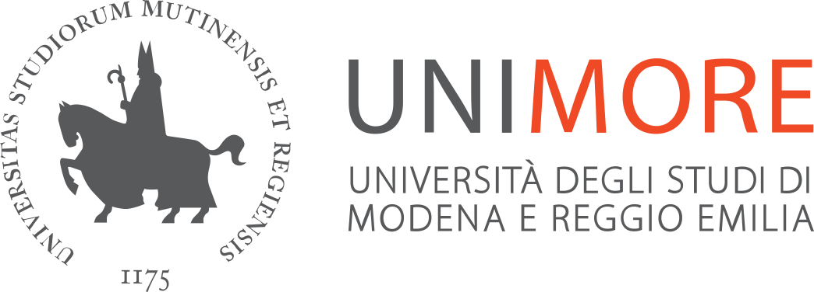

**ORIENTATION AND DISORIENTATION:**

**KANTIAN THEMES IN ANALYTIC PHILOSOPHY**

**Midterm Conference of the S.I.F.A. (Italian Society for Analytic Philosophy)**

**Centro Internazionale Loris Malaguzzi**

**Reggio Emilia, 2-3 December 2024**

**2 December, 2024**

**9:00** **Registration**

**10:00-10:15** **Opening**

Carla Bagnoli (University of Modena & Reggio Emilia, National Academy Lincei)

Alberto Voltolini (University of Turin, President of SIFA)

**Plenary** [Sala Kuwait]

**Chair: Alberto Voltolini** (University of Turin)

**10:30-12:00** Keynote Speaker Andrea Kern (Leipzig University), *Skepticism, Minimal Kantianism, and the Idea of Reason’s Self-Limitation*

**12:00-12:15 Coffee Break**

Session *Agency* [Sala Kuwait]

**Chair: Carla Bagnoli** (University of Modena and Reggio Emilia)

**12:15-12:45** Alexandra Newton (UC-Riverside), *Against the Speciesist Conception of Kantian Persons*

**12:45-13:15** Jeremy Fix (Oxford University), *Orientation and Agency*

Session *Epistemology* [Sala Colonne]

**Chair: Francesco Cagnin** (University of Modena and Reggio Emilia)

**12:15-12:45** Anita Leirfall (University of Bergen), *Kant on the Relation between Orientation and Feeling*

**12:45-13:15** Alice Van’t Hoff (University of Vienna), *Kantian Orientation contra Fragmentalism*

**13:15-15:00 Lunch** **at *Pause***

**14:30-15:00** Meeting SIFA

SYMPOSIUM *Disorientation* [Sala Kuwait]

**Chair: Matteo D’Alfonso** (University of Ferrara)

**15:00-15:30** Matteo Bianchin (University of Roma Tor Vergata), *Alienation and Disorientation*

**15:30-16:00** Josep E. Corbí (University of Valencia), *Living the World: Disorientation and the Practical Question*

**16:00-16:30** Carla Bagnoli (University of Modena and Reggio Emilia), *Disorientation and the Collapse of the Collective*

Session *Epistemology*

**Chair: Luca Forgione** (University of Naples Federico II)

**15:00-15:30** Samuel Descarreaux (University of Ottawa & Université de Lorraine), *Epistemic Normativity in 19 Century Naturalized Kantianism*

**15:30-16:00** Jakub Kańtoch (Jagiellonian University), *Idealism and the Orientation of Thought: Rödl versus Kant*

**16:00-16:30** Kuizhi Lewis Wang (Boston University), *Kant’s Theory of Reason for Beliefs*

**16:30-17:00** Till Hoeppner (Ashoka University), *How Orientation in Thought Depends on Orientation in Experience: Kant, Strawson, and the Possibility of a Cognition Through Concepts*

**17:00-17:15 Coffee Break**

**Plenary Session** [Sala Kuwait]

**Chair: Carla Bagnoli** (University Modena and Reggio Emilia)

**17:15-18:45** Keynote Speaker Andrew Chignell (Princeton University), *The Primacy of the Practical (and is Kant an Early Encroachment Theorist?)*

**20:00 Social Dinner at *Macramè***

**3 December, 2024**

**Plenary Session** [Sala Kuwait]

**Chair: Carla Bagnoli** (University Modena and Reggio Emilia)

**9:30-11:00** Keynote Katharina Bauer (Erasmus University Rotterdam): *Hope and Moral Courage. Individual and Collective Dimensions*

**11:00-11:15 Coffee Break**

Session *Philosophy of Law* [Sala Kuwait]

**Chair: Chiara Lapi** (University Modena and Reggio Emilia)

**11:15-11:45** Vincenzo Pacillo (University of Modena and Reggio Emilia), Basira Hussen (University of Modena and Reggio Emilia), *Disorientation, Conscientious Objection, and Kantian Ethics in Italian End of Life Legislation*

**11:45-12:15** Natalia Witosza (Jagiellonian University), *Rethinking Free Speech in Digital Age. A Kantian Perspective on Restriction*

**12:15-12:45** Fabio Franceschi (University of Rome I), Alessandra Viani (University of Rome I), *The Right to Peace. From the Kantian Idea of Perpetual Peace to 2016 UNGA Declaration*

Session *Miscellanea* [Sala Colonne]

**Chair: Manuel Marsico** (University of Genova)

**11:15-11:45** Andrea Tortoreto (Unipegaso), *Orientation, Agency and Games: Reinterpreting Kant’s Metaphor*

**11:45-12:15** Steven Woodworth (John Cabot University), *The Guise of the Good Thesis as Constitutive of Our Moral Orientation*

**12:15-12:45**  Bo Flemming Loxtermann (University of Siegen), *On the Relation of Direct Experience and Philosophical Cognition*

**12:45-14:30 Lunch at *Pause***

SYMPOSIUM *Knowledge* [Sala Kuwait]

**Chair: Carla Bagnoli** (University of Modena and Reggio Emilia)

**14:30-15:00** Thomas Pendlebury (University of Chicago), *The Objects of Kant’s Copernican Assumption*

**15:00-15:30** Mario Schärli (Humboldt University Berlin), *Needs of Theoretical Reason*

15:30-15:45 Coffee Break

**Chair: Lorenzo Manera** (University of Modena and Reggio Emilia)

**15:45-16:15** Juan Andrés Vargas Cartajena (Universidad Diego Portales), *From Kant to Hegel: Inferentialism and Self-Consciousness*

**16:15-16:45** Luca Forgione (University of Naples Federico II), *From Descriptive Metaphysic to the Primacy of Metaphisics**: Strawson and Peacocke on ‘I think’*

Session *Ethics* [Sala Colonne]

**Chair: Antonino Falduto** (University of Ferrara)

**14:30-15:00** Stefano Pinzan (Vita-Salute San Raffaele University, Milan), *Orientating Us in a (Morally) Better Way: Sympathy Cultivation in Kant*

**15:00-15:30** Jacopo Morelli (University of Modena and Reggio Emilia), *Moral Orientation, Empirical Inputs and Universalizability*

15:00-15:15 Coffee Break

**Chair: Roberto Mordacci** (Istituto Universitario San Raffaele)

**15:45-16:15** Giulia Battistoni (University of Verona), *Orienting Action: Kant’s vs. Hegel’s Approaches to the State of Necessity*

**16:15-16:45** Francesco Emanuelli (University of Modena and Reggio Emilia) *Kant, Constituvism, and the Inescapability Thesis*

**16:45** – **17:00** Closing Remarks [Sala Kuwait]